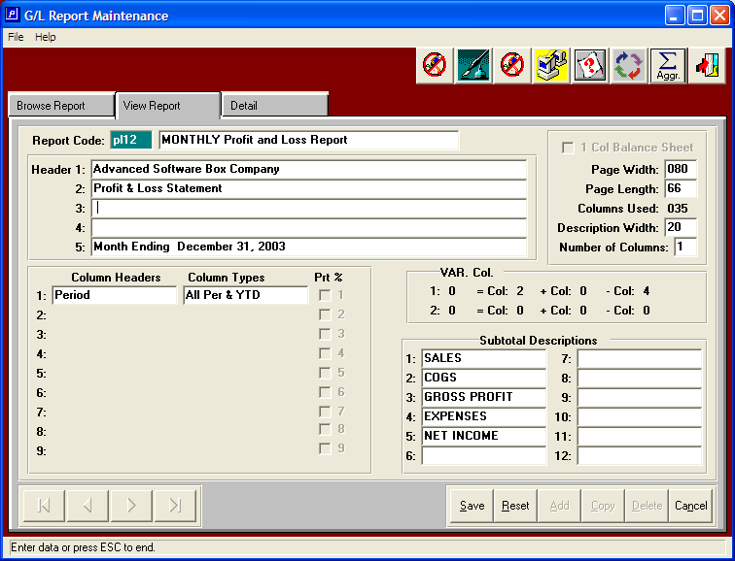

NEW 13 Period / 12 Month Profit and Loss Statement

This is a great new report. Note, the above Column Headings and Column Types are set to invoke this new report. The balance of your financial report would be defined exactly as the original. This will give you the ability to see the entire year compared against the entire last year.

